Міністерство освіти і науки України

Державний університет “Житомирська політехніка”

Кафедра інженерії програмного забезпечення

Група: ВТ-21-1[1]

Програмування мовою Python

Лабораторна робота № 11

«Робота з Flask»

Виконав: Бабушко А. С.

Прийняв: Морозов Д. С.

***Мета роботи:*** ознайомитися з роботою з веб-фреймворка Flask.

***Хід роботи:***

***Завдання на лабораторну роботу:***

Використовуючи веб-фреймворк Flask і створіть сайт музичного гурту/виконавця з наступним функціоналом:

1. Сайт має містити сторінки «Головна», «Про проект», «Історія гурту» і сторінки окремих альбомів.
2. Реалізуйте можливість додавання, видалення і редагування сторінок альбомів для авторизованих користувачів.
3. Обмеження на використання будь-яких front-end технологій на сайті немає.
4. Розгорніть ваш Flask-проект на платформі Heroku

***Лістинг програми:***

1. ***app.py:***

*from* albumBand *import* app  
  
*if* __name__ == '__main__':  
 app.run(debug=*True*)

1. ***__init__.py:***

*from* flask *import* Flask  
*from* flask_login *import* LoginManager  
  
app = Flask(__name__)  
app.config['SECRET_KEY'] = '089ede1b5ebaebb10fa0f3328afb3864'  
  
login_manager = LoginManager()  
login_manager.init_app(app)  
login_manager.login_view = 'login'  
  
*from* albumBand *import* routes

1. ***routes.py:***

*from* albumBand *import* app  
*from* flask *import* render_template, flash, redirect, url_for, request  
*from* albumBand.forms *import* RegistrationForm, LoginForm, PostForm  
*from* albumBand.models *import* User, Posts  
*from* flask_login *import* login_required, login_user, logout_user, current_user  
*import* datetime  
  
albums: list[Posts] = [  
 Posts('Andrii Babushko', '2018', 'Highway to Hell', '1978'),  
 Posts('Ihor Dzhus', '2022', 'Iron Man 2', '2010'),  
 Posts('Karina Zbun', '2023', 'Black in Black', '1980'),  
 Posts('Olexander Vignich', '2021', 'Power Up', '2020'),  
 Posts('Olexander Shumskii', '2015', 'Powerage', '1978')  
]  
  
user: User = User()  
  
  
@app.route('/')  
@app.route('/index')  
*def* index():  
 *return* render_template('index.html', albums=albums, user=user)  
  
  
@app.route('/about/')  
*def* about():  
 *return* render_template('about.html', title='About project', user=user)  
  
  
@app.route('/about_band/')  
*def* about_band():  
 *return* render_template('about_band.html', title='Band history', user=user)  
  
  
@app.route('/login/', methods=['GET', 'POST'])  
*def* login():  
 login_form: LoginForm = LoginForm()  
  
 *if* login_form.validate_on_submit():  
 *if* login_form.email.data == 'admin@gmail.com' *and* login_form.password.data == 'admin':  
 init_user('Admin', login_form.email.data, login_form.password.data, *True*)  
 flash('You have been logged in!', 'success')  
 *return* redirect(url_for('index', user=user))  
 *else*:  
 flash('Login unsuccessful. Please, check username and password!', 'danger')  
  
 *return* render_template('login.html', title='Login', form=login_form, user=user)  
  
  
@app.route("/logout")  
*def* logout():  
 logout_user()  
 user.is_authenticated = *False  
 return* redirect(url_for('index', user=user))  
  
  
@app.route('/register/', methods=['GET', 'POST'])  
*def* register():  
 registration_form: RegistrationForm = RegistrationForm()  
  
 *if* registration_form.validate_on_submit():  
 init_user(registration_form.username.data, registration_form.email.data, registration_form.password.data, *False*)  
 flash(f'Account was successfully created! Now you are able to log in.', 'success')  
 *return* redirect(url_for('index', user=user))  
  
 *return* render_template('register.html', title='Registration', form=registration_form, user=user)  
  
  
@app.route('/post/new', methods=['GET', 'POST'])  
*def* new_post():  
 post_form: PostForm = PostForm()  
  
 *if* post_form.validate_on_submit():  
 today = datetime.date.today()  
 albums.append(Posts(user.username, today.strftime("%Y"), post_form.title.data, post_form.album_date.data))  
 flash('Your post has been created!', 'success')  
 *return* redirect(url_for('index', user=user))  
  
 *return* render_template('create_post.html', title='New post', form=post_form, user=user, legend='New post')  
  
  
@app.route('/post/<int:post_id>', methods=['GET', 'POST'])  
*def* post(post_id: int):  
 searched_album: Posts = get_searched_album(post_id)  
 *return* render_template('post.html', title=searched_album.title, album=searched_album, user=user)  
  
  
@app.route('/post/<int:post_id>/update', methods=['GET', 'POST'])  
*def* update_post(post_id: int):  
 searched_album: Posts = get_searched_album(post_id)  
 post_form: PostForm = PostForm()  
  
 *if* post_form.validate_on_submit():  
 *for* album *in* albums:  
 *if* album.post_id == post_id:  
 album.title = post_form.title.data  
 album.album_date = post_form.album_date.data  
 flash('Your post has been updated!', 'success')  
 *return* redirect(url_for('post', post_id=album.post_id, user=user))  
 *elif* request.method == 'GET':  
 post_form.title.data = searched_album.title  
 post_form.album_date.data = searched_album.album_date  
  
 *return* render_template('create_post.html', title='Update post', form=post_form, user=user, legend='Update post')  
  
  
@app.route('/post/<int:post_id>/delete', methods=['GET', 'POST'])  
*def* delete_post(post_id):  
 *for* album *in* albums:  
 *if* album.post_id == post_id:  
 albums.remove(album)  
  
 flash('Your post has been deleted!', 'success')  
 *return* redirect(url_for('index', user=user))  
  
  
*def* init_user(username: str, email: str, password: str, is_authenticated: bool):  
 user.username = username  
 user.email = email  
 user.password = password  
 user.is_authenticated = is_authenticated  
  
  
*def* get_searched_album(post_id):  
 *for* album *in* albums:  
 *if* album.post_id == post_id:  
 *return* album  
 *return None*

1. ***forms.py:***

*from* flask_wtf *import* FlaskForm  
*from* wtforms *import* StringField, PasswordField, SubmitField, BooleanField, DateTimeField  
*from* wtforms.validators *import* DataRequired, Length, Email, EqualTo  
  
  
*class* RegistrationForm(FlaskForm):  
 username = StringField('Username', validators=[DataRequired(), Length(min=3, max=15)])  
 email = StringField('Email address', validators=[DataRequired(), Email()])  
 password = PasswordField('Password', validators=[DataRequired()])  
 confirm_password = PasswordField('Confirm password', validators=[DataRequired(), EqualTo('password')])  
 submit = SubmitField('Sign Up')  
  
  
*class* LoginForm(FlaskForm):  
 email = StringField('Email address', validators=[DataRequired(), Email()])  
 password = PasswordField('Password', validators=[DataRequired()])  
 remember = BooleanField('Remember me')  
 submit = SubmitField('Login')  
  
  
*class* PostForm(FlaskForm):  
 title = StringField('Title', validators=[DataRequired()])  
 album_date = StringField('Album date', validators=[DataRequired()])  
 submit = SubmitField('Post')

1. ***models.py:***

*from* flask_login *import* UserMixin  
*from* albumBand *import* login_manager  
*import* random  
  
  
@login_manager.user_loader  
*def* load_user(user_id):  
 *return* User.id  
  
  
*class* User(UserMixin):  
 id = random.getrandbits(64)  
 username: str  
 email: str  
 image_file: str  
 password: str  
 posts: *None* is_authenticated: bool = *False  
  
  
class* Posts:  
 *def __init__*(*self*, author: str, date_posted: str, title: str, album_date: str):  
 *self*.author: str = author  
 *self*.date_posted: str = date_posted  
 *self*.title: str = title  
 *self*.album_date: str = album_date  
 *self*.post_id: int = random.getrandbits(64)

1. ***index.html:***

{% extends "layout.html" %}  
{% block *content* %}  
 {% for *album* in *albums* %}  
 <article *class*="media content-section">  
 <div *class*="media-body">  
 <div *class*="article-metadata">  
 <a *class*="mr-2" *href*="#">{{ *album*.*author* }}</a>  
 <small *class*="text-muted p-2">{{ *album*.*date_posted* }}</small>  
 </div>  
 <h2><a *class*="article-title" *href*="{{ *url_for*('post', *post_id*=*album*.*post_id*) }}">{{ *album*.*title* }}</a></h2>  
 <p *class*="article-content">{{ *album*.*album_date* }}</p>  
 </div>  
 </article>  
 {% endfor %}  
{% endblock *content* %}

1. ***layout.html:***

<!doctype *html*>  
<html *lang*="en">  
<head>  
 <meta *charset*="UTF-8">  
 <meta *name*="viewport" *content*="width=device-width, initial-scale=1.0, minimum-scale=1.0">  
 <meta *http-equiv*="X-UA-Compatible" *content*="ie=edge">  
  
 <link *href*="https://cdn.jsdelivr.net/npm/bootstrap@5.0.2/dist/css/bootstrap.min.css" *rel*="stylesheet"  
 *integrity*="sha384-EVSTQN3/azprG1Anm3QDgpJLIm9Nao0Yz1ztcQTwFspd3yD65VohhpuuCOmLASjC" *crossorigin*="anonymous">  
  
 <link *rel*="stylesheet" *type*="text/css" *href*="{{ *url_for*('static', *filename*='styles/style.css') }}">  
  
 {% if *title* %}  
 <title>Music band - {{ *title* }}</title>  
 {% else %}  
 <title>Music band</title>  
 {% endif %}  
</head>  
<body>  
<header *class*="site-header">  
 <nav *class*="navbar navbar-expand-lg navbar-light bg-steel">  
 <div *class*="container">  
 <a *href*="{{ *url_for*('index') }}" *class*="navbar-brand">Music band</a>  
 <button *class*="navbar-toggler" *type*="button" *data-bs-toggle*="collapse" *data-bs-target*="#navbarNav" *aria-controls*="navbarNav" *aria-expanded*="false"  
 *aria-label*="Toggle navigation">  
 <span *class*="navbar-toggler-icon"></span>  
 </button>  
 <div *class*="collapse navbar-collapse" *id*="navbarNav">  
 <ul *class*="navbar-nav me-auto mb-2 mb-lg-0">  
 <li *class*="nav-item">  
 <a *class*="nav-link" *href*="{{ *url_for*('about') }}">About project</a>  
 </li>  
 <li *class*="nav-item">  
 <a *class*="nav-link" *href*="{{ *url_for*('about_band') }}">About band</a>  
 </li>  
 </ul>  
 <ul *class*="navbar-nav">  
 {% if *user*.*is_authenticated* %}  
 <li *class*="nav-item">  
 <a *class*="nav-link" *href*="{{ *url_for*('new_post') }}">New post</a>  
 </li>  
 <li *class*="nav-item">  
 <a *class*="nav-link" *href*="{{ *url_for*('logout') }}">Logout</a>  
 </li>  
 {% else %}  
 <li *class*="nav-item">  
 <a *class*="nav-link" *href*="{{ *url_for*('login') }}">Login</a>  
 </li>  
 <li *class*="nav-item">  
 <a *class*="nav-link" *href*="{{ *url_for*('register') }}">Register</a>  
 </li>  
 {% endif %}  
 </ul>  
 </div>  
 </div>  
 </nav>  
</header>  
  
<main *role*="main" *class*="container">  
 <div *class*="row mt-3">  
 <div *class*="col-xl-8 col-lg-8 col-md-12 col-sm-12">  
 {% with *messages* = *get_flashed_messages*(*with_categories*=*True*) %}  
 {% if *messages* %}  
 {% for *category*, *message* in *messages* %}  
 <div *class*="alert alert-{{ *category* }}">  
 {{ *message* }}  
 </div>  
 {% endfor %}  
 {% endif %}  
 {% endwith %}  
 {% block *content* %}{% endblock *content* %}  
 </div>  
 <div *class*="col-xl-4 col-lg-4 col-md-12 col-sm-12">  
 <div *class*="content-section">  
 <h3>Our Sidebar</h3>  
 <p *class*='text-muted'>You can put any information here you'd like.</p>  
 <ul *class*="list-group">  
 <li *class*="list-group-item list-group-item-light">Latest Posts</li>  
 <li *class*="list-group-item list-group-item-light">Announcements</li>  
 <li *class*="list-group-item list-group-item-light">Calendars</li>  
 <li *class*="list-group-item list-group-item-light">etc</li>  
 </ul>  
 </div>  
 </div>  
 </div>  
</main>  
  
  
<script *src*="https://cdn.jsdelivr.net/npm/bootstrap@5.0.2/dist/js/bootstrap.bundle.min.js" *integrity*="sha384-MrcW6ZMFYlzcLA8Nl+NtUVF0sA7MsXsP1UyJoMp4YLEuNSfAP+JcXn/tWtIaxVXM"  
 *crossorigin*="anonymous"></script>  
</body>  
</html>

1. ***about.html:***

{% extends "layout.html" %}  
{% block *content* %}  
 <div *class*="d-flex flex-row flex-wrap justify-content-between">  
 <div *class*="col-xl-12 col-lg-12 col-md-12 col-sm-12">  
 <h1 *class*="h1" *style*="text-align: center">  
 <img *src*="../static/img/project_imgs/raccoon_icon_126074.png" *alt*="ACDC poster" *class*=" mx-auto" *width*="75">  
 About project  
 <img *src*="../static/img/project_imgs/raccoon_icon_126074.png" *alt*="ACDC poster" *class*=" mx-auto" *width*="75">  
 </h1>  
 <p *class*="mb-4">  
 <strong>Lab 11. </strong>Python - Flask.  
 </p>  
 <p *class*="mb-4">  
 Made by &copy;Andrii Babushko. Group: WT-21-1(1).  
 </p>  
 <p *class*="mb-4">  
 Project repository <a *href*="https://github.com/AndriiBabushko/Python">here</a>  
 </p>  
 </div>  
 </div>  
{% endblock *content* %}

1. ***about_band.html:***

{% extends "layout.html" %}  
{% block *content* %}  
 <div *class*="d-flex flex-row flex-wrap justify-content-between">  
 <div *class*="col-xl-4 col-lg-4 col-md-12 col-sm-12">  
 <img *src*="../static/img/band_imgs/ACDC_poster.jpg" *alt*="ACDC poster" *class*="rounded mx-auto d-block" *width*="350">  
 <img *src*="../static/img/band_imgs/ACDC_art.jpg" *alt*="ACDC art" *class*="rounded mx-auto d-block" *width*="365">  
 </div>  
 <div *class*="col-xl-6 col-lg-4 col-md-12 col-sm-12">  
 <h1 *class*="h1">ACDC</h1>  
 <p *class*="mb-4">  
 AC/DC are an Australian rock band formed in Sydney, New South Wales, Australia in 1973 by Scottish-born brothers Malcolm and Angus Young. Their music has been  
 variously described as hard rock, blues rock, and heavy metal, but the band calls it simply "rock and roll".  
 </p>  
 <p *class*="mb-4">  
 AC/DC underwent several line-up changes before releasing their first album, 1975's High Voltage. Membership subsequently stabilised around the Young brothers,  
 singer Bon Scott, drummer Phil Rudd, and bassist Mark Evans. Evans was fired from the band in 1977 and replaced by Cliff Williams, who has appeared on every AC/DC  
 album since 1978's Powerage. In February 1980, about seven months after the release of their breakthrough album Highway to Hell, Scott died of acute alcohol  
 poisoning after a night of heavy drinking. AC/DC considered disbanding, but at Scott's family's request, the remaining members opted to continue the band,  
 bringing in longtime Geordie vocalist Brian Johnson as Scott's replacement. Later that year, the band released their first album with Johnson, Back in Black,  
 which was dedicated to Scott's memory. The album launched AC/DC to new heights of success and became one of the best selling albums of all time.  
 </p>  
 <p *class*="mb-4">  
 The band's eighth studio album, For Those About to Rock We Salute You (1981), was their first album to reach number one in the United States. Prior to the release  
 of their next album, Flick of the Switch (1983), Rudd left the band and was replaced by Simon Wright, being in turn replaced by Chris Slade in 1989. The band  
 experienced a commercial resurgence in the early nineties with the release of their twelfth studio album The Razors Edge (1990); it was their only album to feature  
 Slade, who was replaced by the returning Rudd in 1994. Rudd has since recorded five more albums with the band, starting with, and including, Ballbreaker (1995).  
 Their fifteenth studio album Black Ice was the second-highest-selling album of 2008, and their biggest chart hit since For Those About to Rock, eventually reaching  
 No.1 worldwide.  
 </p>  
 <p *class*="mb-4">  
 The band's line-up remained the same for twenty years, until 2014 with Malcolm Young's retirement due to early-onset dementia (he died in 2017) and Rudd's legal  
 troubles. Malcolm was replaced by his nephew Stevie Young, who debuted on AC/DC's 2014 album Rock or Bust, and on its accompanying tour, previous drummer Chris  
 Slade filled in for Rudd. In 2016, Johnson was advised to stop touring due to worsening hearing loss. Guns N' Roses frontman Axl Rose stepped in as the band's  
 vocalist for the remainder of that year's dates. Long-term bass player and background vocalist Cliff Williams retired from AC/DC at the end of the Rock or Bust tour  
 in 2016 and the group entered a four-year hiatus. A reunion of the Rock or Bust lineup was announced in September 2020 and the band's seventeenth studio album Power  
 Up was released two months later.  
 </p>  
 <p *class*="mb-4">  
 AC/DC have sold more than 200 million records worldwide, including 75 million albums in the United States, making them the ninth-highest-selling artist in the  
 United States and the 16th-best-selling artist worldwide. Back in Black has sold an estimated 50 million units worldwide, making it the  
 second-highest-selling album by any artist, and the highest-selling album by any band. The album has sold 25 million units in the US, where it is the fourth  
 highest-selling album of all time. AC/DC were inducted into the Rock and Roll Hall of Fame on 10 March 2003. AC/DC ranked fourth on VH1's list of the "100  
 Greatest Artists of Hard Rock" and were named the seventh "Greatest Heavy Metal Band of All Time" by MTV. In 2004, AC/DC ranked No. 72 on the Rolling  
 Stone list of the "100 Greatest Artists of All Time". Producer Rick Rubin, who wrote an essay on the band for the Rolling Stone list, referred to AC/DC as "the  
 greatest rock and roll band of all time". In 2010, VH1 ranked AC/DC number 23 in its list of the "100 Greatest Artists of All Time".  
 </p>  
 </div>  
 </div>  
{% endblock *content* %}

1. ***login.html:***

{% extends "layout.html" %}  
{% block *content* %}  
 <div *class*="content-section">  
 <form *action*="" *method*="post">  
 {{ *form*.*hidden_tag*() }}  
 <fieldset *class*="form-group">  
 <legend *class*="border-bottom mb-4">Log in!</legend>  
 <div *class*="form-group mb-3">  
 {{ *form*.*email*.*label*(*class*="form-label") }}  
  
 {% if *form*.*email*.*errors* %}  
 {{ *form*.*email*(*class*="form-control form-control-lg is-invalid") }}  
 <div *class*="invalid-feedback">  
 {% for *error* in *form*.*email*.*errors* %}  
 <span>{{ *error* }}</span>  
 {% endfor %}  
 </div>  
 {% else %}  
 {{ *form*.*email*(*class*="form-control form-control-lg") }}  
 {% endif %}  
 </div>  
 <div *class*="form-group mb-3">  
 {{ *form*.*password*.*label*(*class*="form-label") }}  
  
 {% if *form*.*password*.*errors* %}  
 {{ *form*.*password*(*class*="form-control form-control-lg is-invalid") }}  
 <div *class*="invalid-feedback">  
 {% for *error* in *form*.*password*.*errors* %}  
 <span>{{ *error* }}</span>  
 {% endfor %}  
 </div>  
 {% else %}  
 {{ *form*.*password*(*class*="form-control form-control-lg") }}  
 {% endif %}  
 </div>  
 <div *class*="form-check">  
 {{ *form*.*remember*(*class*="form-check-input") }}  
 {{ *form*.*remember*.*label*(*class*="form-check-label") }}  
 </div>  
 </fieldset>  
 <div *class*="form-group mb-3 mt-3">  
 {{ *form*.*submit*(*class*="btn btn-outline-info") }}  
 </div>  
 <small *class*="text-muted">  
 <a *href*="#">Forgot password?</a>  
 </small>  
 </form>  
 </div>  
 <div *class*="border-top pt-3 pb-3">  
 <small *class*="text-muted">  
 Need an account? <a *href*="{{ *url_for*('register') }}" *class*="ml-2">Sign up now!</a>  
 </small>  
 </div>  
{% endblock *content* %}

1. ***register.html:***

{% extends "layout.html" %}  
{% block *content* %}  
 <div *class*="content-section">  
 <form *action*="" *method*="post">  
 {{ *form*.*hidden_tag*() }}  
 <fieldset *class*="form-group">  
 <legend *class*="border-bottom mb-4">Join to our music band!</legend>  
 <div *class*="form-group mb-3">  
 {{ *form*.*username*.*label*(*class*="form-label") }}  
  
 {% if *form*.*username*.*errors* %}  
 {{ *form*.*username*(*class*="form-control form-control-lg is-invalid") }}  
 <div *class*="invalid-feedback">  
 {% for *error* in *form*.*username*.*errors* %}  
 <span>{{ *error* }}</span>  
 {% endfor %}  
 </div>  
 {% else %}  
 {{ *form*.*username*(*class*="form-control form-control-lg") }}  
 {% endif %}  
 </div>  
 <div *class*="form-group mb-3">  
 {{ *form*.*email*.*label*(*class*="form-label") }}  
  
 {% if *form*.*email*.*errors* %}  
 {{ *form*.*email*(*class*="form-control form-control-lg is-invalid") }}  
 <div *class*="invalid-feedback">  
 {% for *error* in *form*.*email*.*errors* %}  
 <span>{{ *error* }}</span>  
 {% endfor %}  
 </div>  
 {% else %}  
 {{ *form*.*email*(*class*="form-control form-control-lg") }}  
 {% endif %}  
 </div>  
 <div *class*="form-group mb-3">  
 {{ *form*.*password*.*label*(*class*="form-label") }}  
  
 {% if *form*.*password*.*errors* %}  
 {{ *form*.*password*(*class*="form-control form-control-lg is-invalid") }}  
 <div *class*="invalid-feedback">  
 {% for *error* in *form*.*password*.*errors* %}  
 <span>{{ *error* }}</span>  
 {% endfor %}  
 </div>  
 {% else %}  
 {{ *form*.*password*(*class*="form-control form-control-lg") }}  
 {% endif %}  
 </div>  
 <div *class*="form-group mb-3">  
 {{ *form*.*confirm_password*.*label*(*class*="form-label") }}  
  
 {% if *form*.*confirm_password*.*errors* %}  
 {{ *form*.*confirm_password*(*class*="form-control form-control-lg is-invalid") }}  
 <div *class*="invalid-feedback">  
 {% for *error* in *form*.*confirm_password*.*errors* %}  
 <span>{{ *error* }}</span>  
 {% endfor %}  
 </div>  
 {% else %}  
 {{ *form*.*confirm_password*(*class*="form-control form-control-lg") }}  
 {% endif %}  
 </div>  
 </fieldset>  
 <div *class*="form-group mb-3">  
 {{ *form*.*submit*(*class*="btn btn-outline-info") }}  
 </div>  
 </form>  
 </div>  
 <div *class*="border-top pt-3 pb-3">  
 <small *class*="text-muted">  
 Already have an account? <a *href*="{{ *url_for*('login') }}" *class*="ml-2">Sign in</a>  
 </small>  
 </div>  
{% endblock *content* %}

1. ***post.html:***

{% extends "layout.html" %}  
{% block *content* %}  
 <article *class*="media content-section">  
 <div *class*="media-body">  
 <div *class*="article-metadata">  
 <a *class*="mr-2" *href*="#">{{ *album*.*author* }}</a>  
 <small *class*="text-muted p-2">{{ *album*.*date_posted* }}</small>  
 <div>  
 <a *href*="{{ *url_for*('update_post', *post_id*=*album*.*post_id*) }}" *class*="btn btn-secondary btn-sm mt-1 mb-1">Update</a>  
 <a *href*="{{ *url_for*('delete_post', *post_id*=*album*.*post_id*) }}" *class*="btn btn-danger btn-sm m-1">Delete</a>  
 </div>  
 </div>  
 <h2 *class*="article-title">{{ *album*.*title* }}</h2>  
 <p *class*="article-content">{{ *album*.*album_date* }}</p>  
 </div>  
 </article>  
{% endblock *content* %}

1. ***create_post.html:***

{% extends "layout.html" %}  
{% block *content* %}  
 <div *class*="content-section">  
 <form *action*="" *method*="post">  
 {{ *form*.*hidden_tag*() }}  
 <fieldset *class*="form-group">  
 <legend *class*="border-bottom mb-4">{{ *legend* }}</legend>  
 <div *class*="form-group mb-3">  
 {{ *form*.*title*.*label*(*class*="form-label") }}  
  
 {% if *form*.*title*.*errors* %}  
 {{ *form*.*title*(*class*="form-control form-control-lg is-invalid") }}  
 <div *class*="invalid-feedback">  
 {% for *error* in *form*.*title*.*errors* %}  
 <span>{{ *error* }}</span>  
 {% endfor %}  
 </div>  
 {% else %}  
 {{ *form*.*title*(*class*="form-control form-control-lg") }}  
 {% endif %}  
 </div>  
 <div *class*="form-group mb-3">  
 {{ *form*.*album_date*.*label*(*class*="form-label") }}  
  
 {% if *form*.*album_date*.*errors* %}  
 {{ *form*.*album_date*(*class*="form-control form-control-lg is-invalid") }}  
 <div *class*="invalid-feedback">  
 {% for *error* in *form*.*album_date*.*errors* %}  
 <span>{{ *error* }}</span>  
 {% endfor %}  
 </div>  
 {% else %}  
 {{ *form*.*album_date*(*class*="form-control form-control-lg") }}  
 {% endif %}  
 </div>  
 </fieldset>  
 <div *class*="form-group mb-3 mt-3">  
 {{ *form*.*submit*(*class*="btn btn-outline-info") }}  
 </div>  
 </form>  
 </div>  
{% endblock *content* %}

1. ***style.sass:***

body  
 background: #fafafa  
 color: #333333  
  
h1, h2, h3, h4, h5, h6  
 color: #444444  
  
.bg-steel  
 background-color: #5e9cce  
  
.site-header .navbar-nav .nav-link:hover  
 color: #d7d7d7  
  
.content-section  
 background: #ffffff  
 padding: 10px 20px  
 border: 1px solid #dddddd  
 border-radius: 3px  
 margin-bottom: 20px  
  
.article-title  
 color: #444444  
  
a.article-title:hover  
 color: #428bca  
  
 text-decoration: none  
  
.article-content  
 white-space: pre-line  
  
.article-img  
 height: 65px  
 width: 65px  
 margin-right: 16px  
  
.article-metadata  
 padding-bottom: 1px  
 margin-bottom: 4px  
 border-bottom: 1px solid #e3e3e3  
  
.article-metadata a:hover  
 color: #333  
 text-decoration: none  
  
.article-svg  
 width: 25px  
 height: 25px  
 vertical-align: middle  
  
.account-img  
 height: 125px  
 width: 125px  
 margin-right: 20px  
 margin-bottom: 16px  
  
.account-heading  
 font-size: 2.5rem

***Результат програми:***

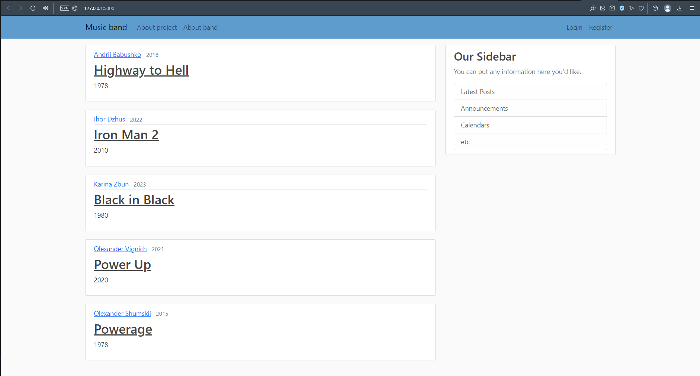

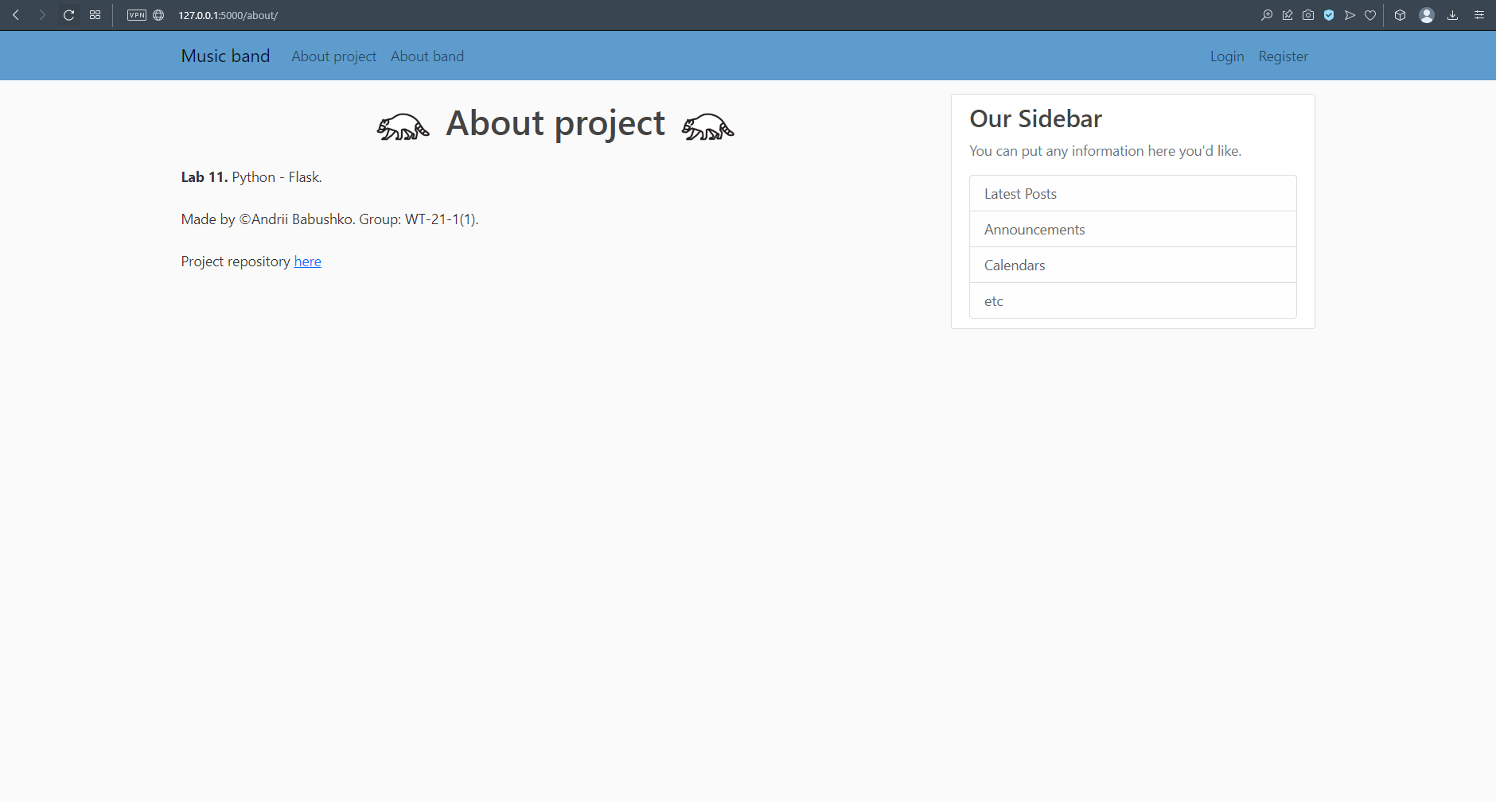

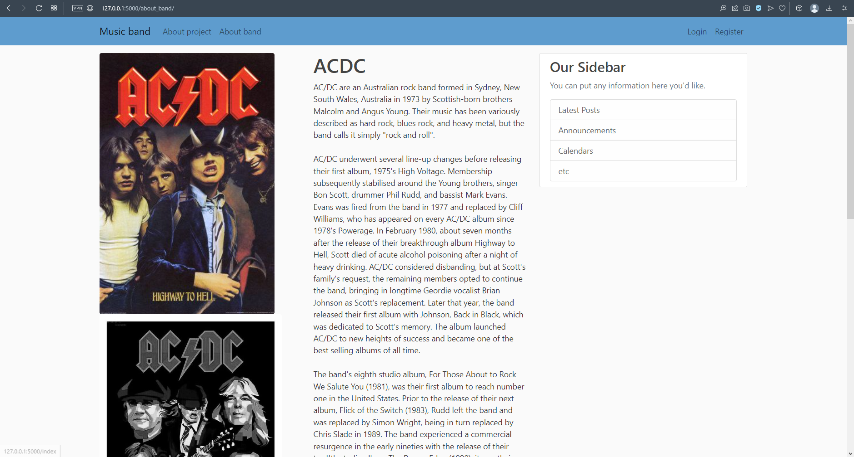

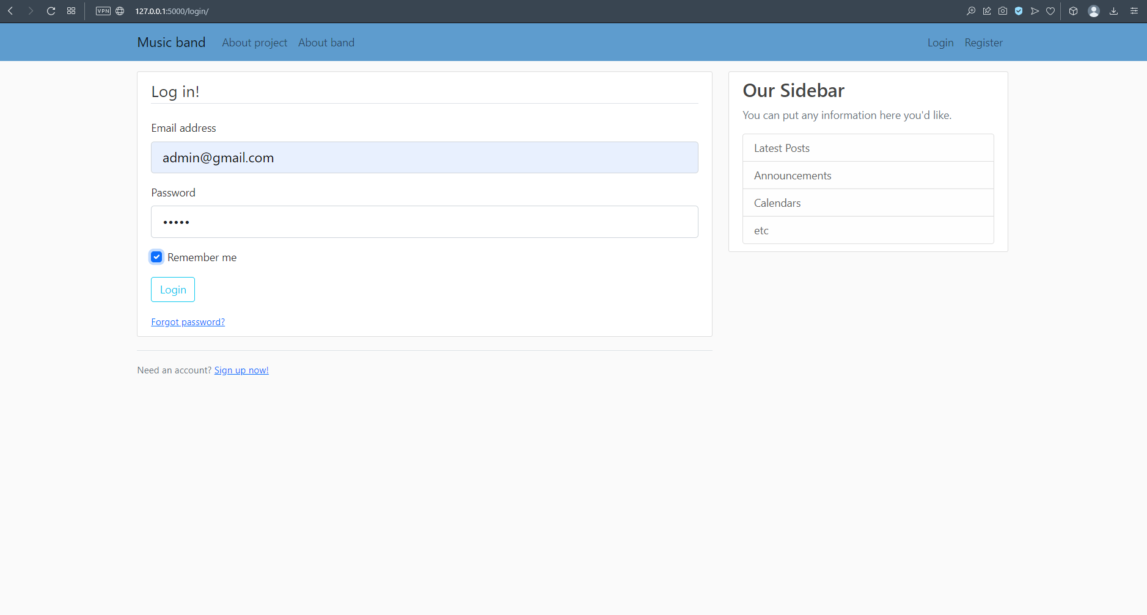

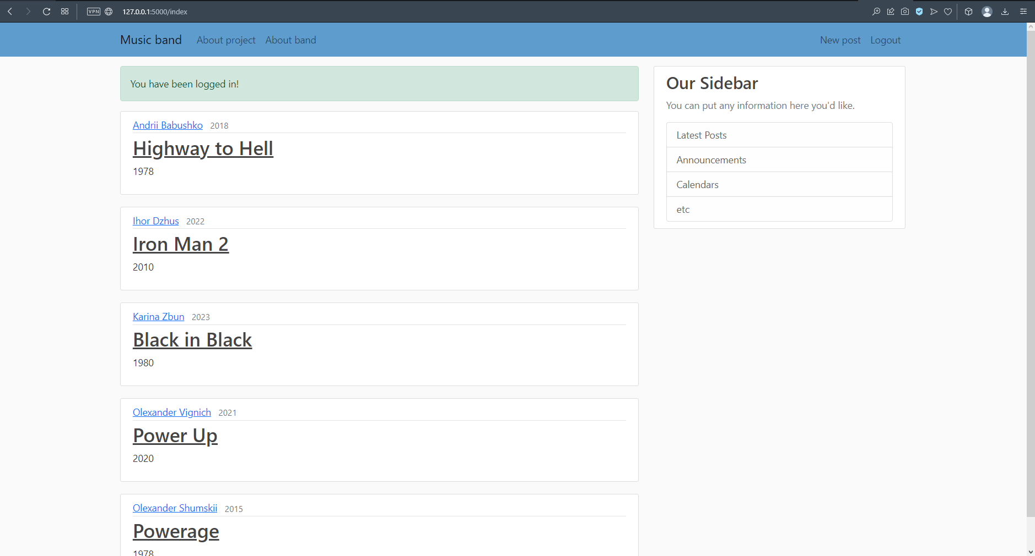

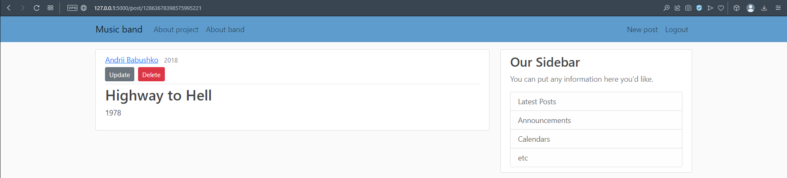

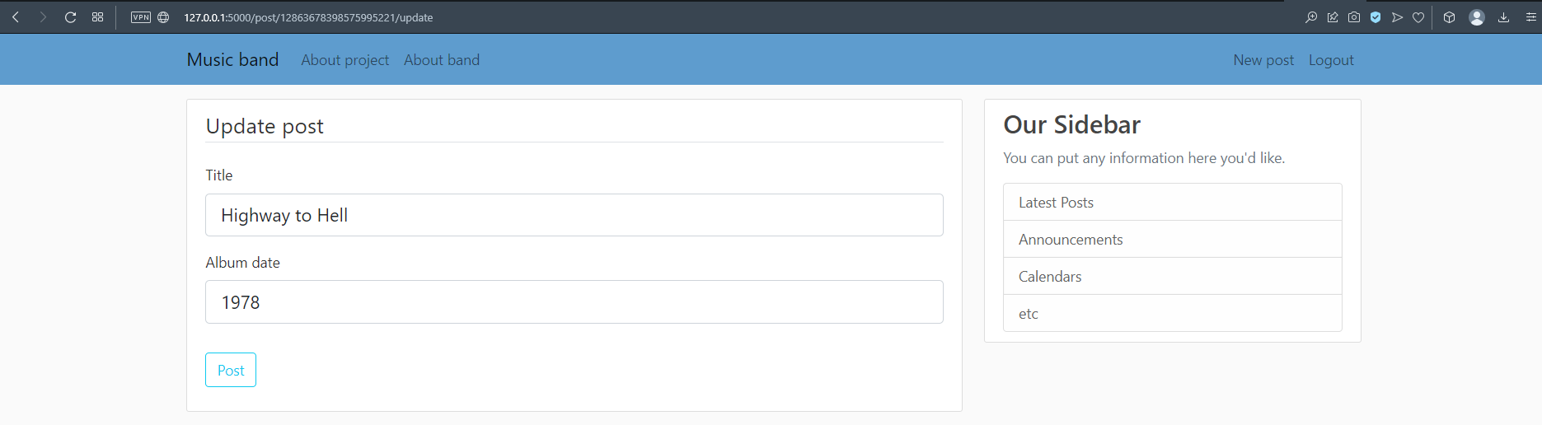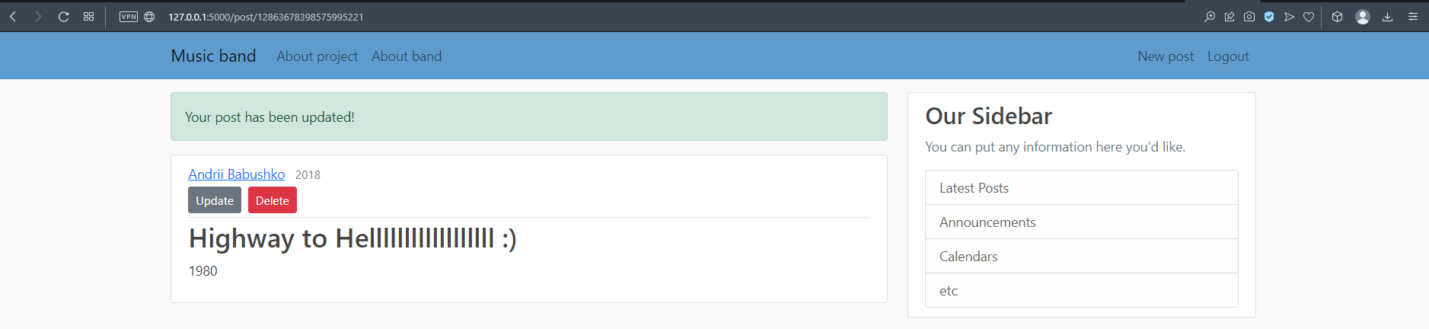

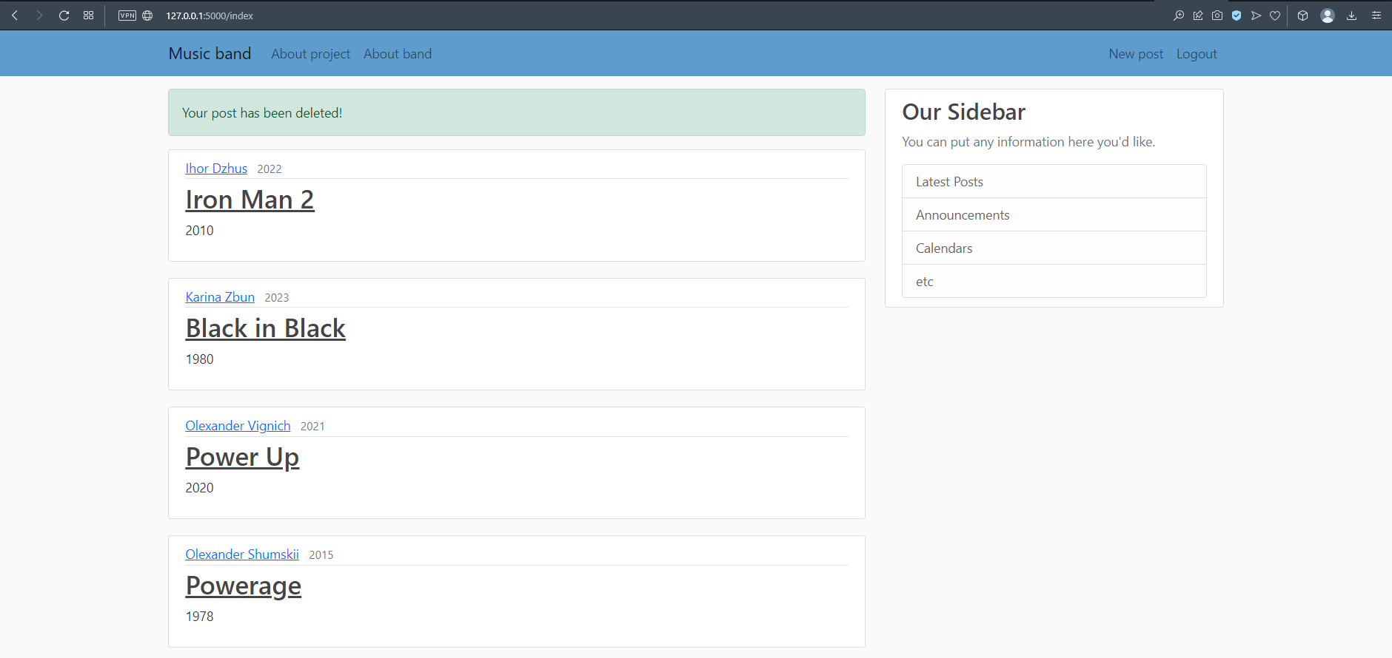

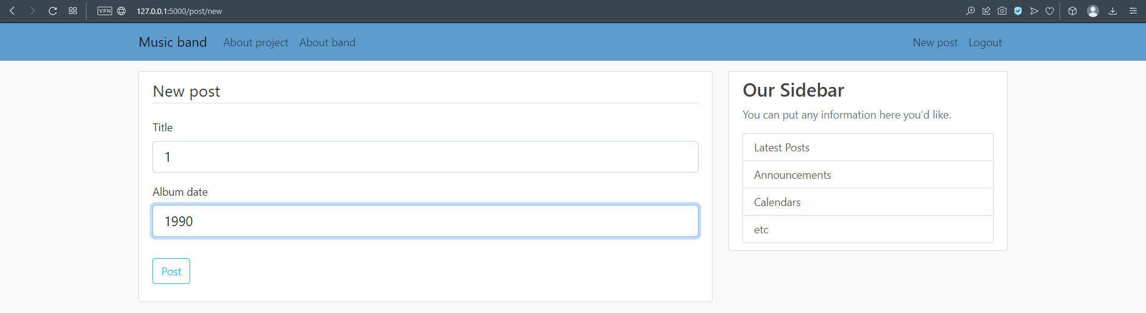

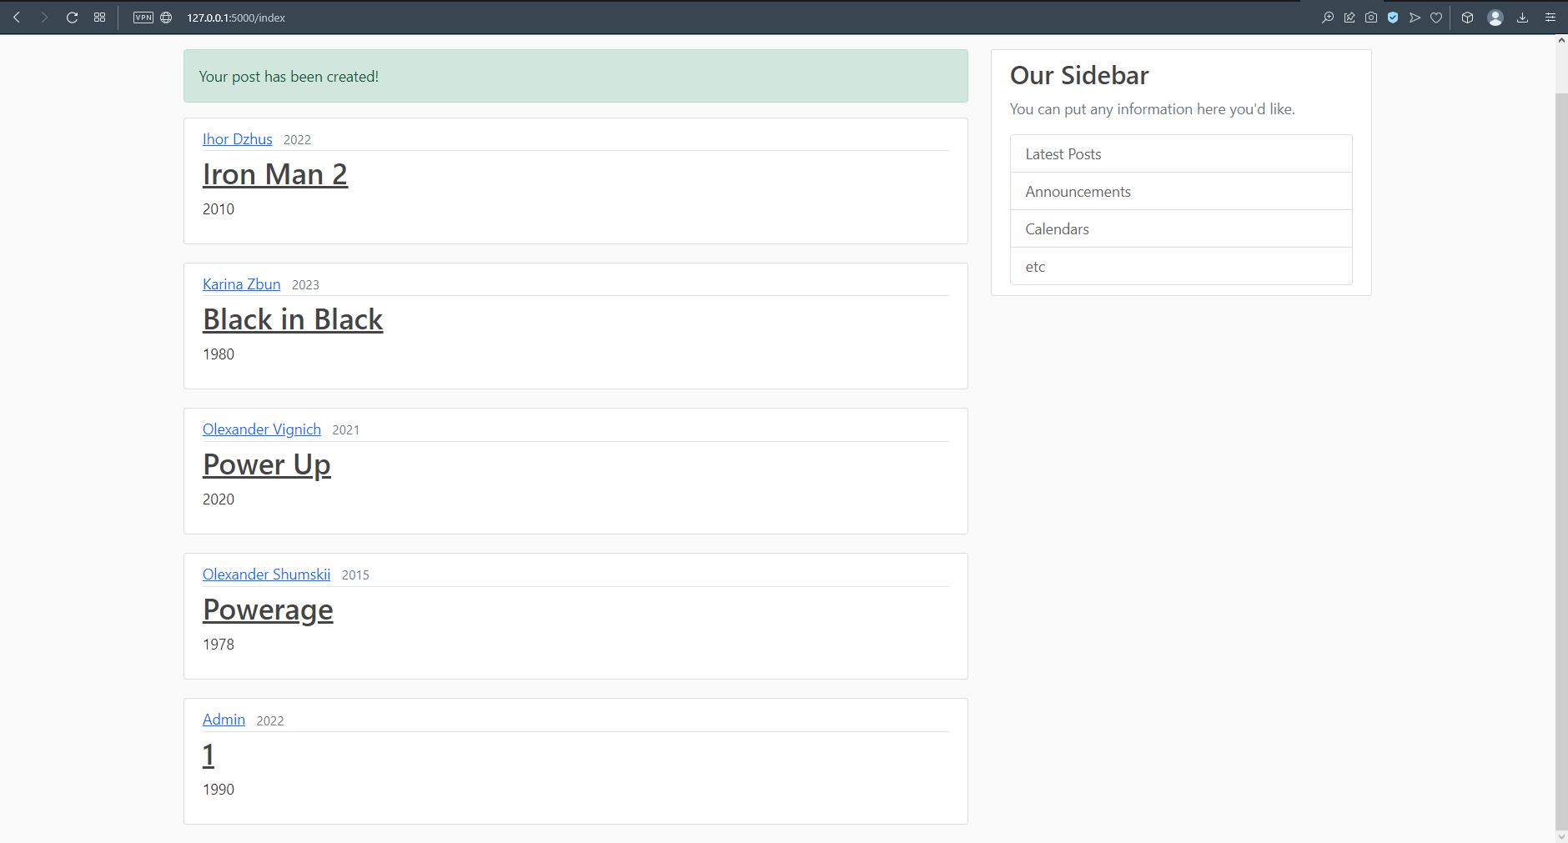

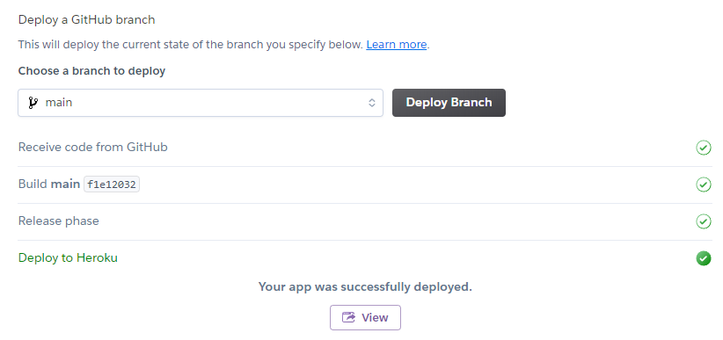

***Висновок:*** під час виконання лабораторної роботи було отримано навички написання сайту з використанням фреймворку Flask та можливостей які надає даний фреймворк.